**Project Report:**

**NDUB Computer Club Management System**

**-by Tasdiqul Huq-06 & Esha Silvia Rozario**

**Table of Contents**

**1.Introduction**

**2.Project Overview**

**3.Database Structure**

**4.Front-End Development**

**5.Back-End Development**

**6.Conclusion**

**1. Introduction**

The NDUB Computer Club Management System is designed to manage the activities, members, committees, and events of the NDUB Computer Club. This project aims to provide an efficient and user-friendly interface for managing club information and ensuring seamless communication among members.

**2. Project Overview**

The project involves creating a dynamic web application with the following features:

*A homepage with information about the club.

*A members page displaying all club members.

*A committees page displaying all committees.

*An events page displaying all events.

*An admin page for adding and deleting members, committees, and events.

**3. Database Structure**

**Tables**

**\*Members :**

1.id (INT): Primary key, auto-incremented.

2.name (VARCHAR): Name of the member.

3.email (VARCHAR): Email of the member.

4.Student_id (VARCHAR): Student ID of the member.

5.year (INT): Year of study.

**\*Committees:**

1.id (INT): Primary key, auto-incremented.

2.committee_name (VARCHAR): Name of the committee.

**\*Events:**

1.id (INT): Primary key, auto-incremented.

2.event_name (VARCHAR): Name of the event.

3. date (DATE): Date of the event.

**Database Connection :**

The db.inc.php file contains the code to connect to the MySQL database:

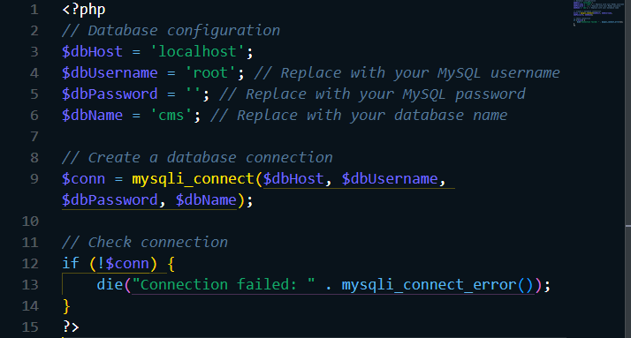**4. Front-End Development**

**Homepage (index.php)**

The homepage provides a welcome message, club information, and a list of upcoming events fetched dynamically from the database.

**Members Page (members.php)**

Displays all members from the database.

**Committees Page (committees.php)**

Displays all committees from the database.

**Events Page (events.php)**

Displays all events from the database.

**Admin Page (add_delete_entries.php)**

Allows admin to add and delete members, committees, and events.

**Add Member (includes/add_member.php)**

Handles adding members to the database.

**Delete Member (includes/delete_member.php)**

Handles deleting members from the database.

**Add Committee (includes/add_committee.php)**

Handles adding committees to the database.

**Delete Committee (includes/delete_committee.php)**

Handles deleting committees from the database.

**Add Event (includes/add_event.php)**

Handles adding events to the database.

**Delete Event (includes/delete_event.php)**

Handles deleting events from the database.

**5. Back-End Development**

**Database Connection**

The includes/db.inc.php file establishes the connection to the MySQL database.

**Data Handling**

The back-end scripts handle CRUD operations for members, committees, and events. The scripts use SQL queries to insert, delete, and retrieve data from the database.

**Dynamic Content**

The PHP scripts embedded in the HTML pages dynamically generate content such as lists of members, committees, and events based on the data retrieved from the database.

**6. Conclusion**

The NDUB Computer Club Management System provides a robust and user-friendly platform for managing the club's activities. With a dynamic web interface and efficient back-end operations, the system ensures seamless management of members, committees, and events, facilitating better communication and coordination within the club.